Element D: Design Concepts Generation, Analysis, and Selection

Concept Development / Brainstorming
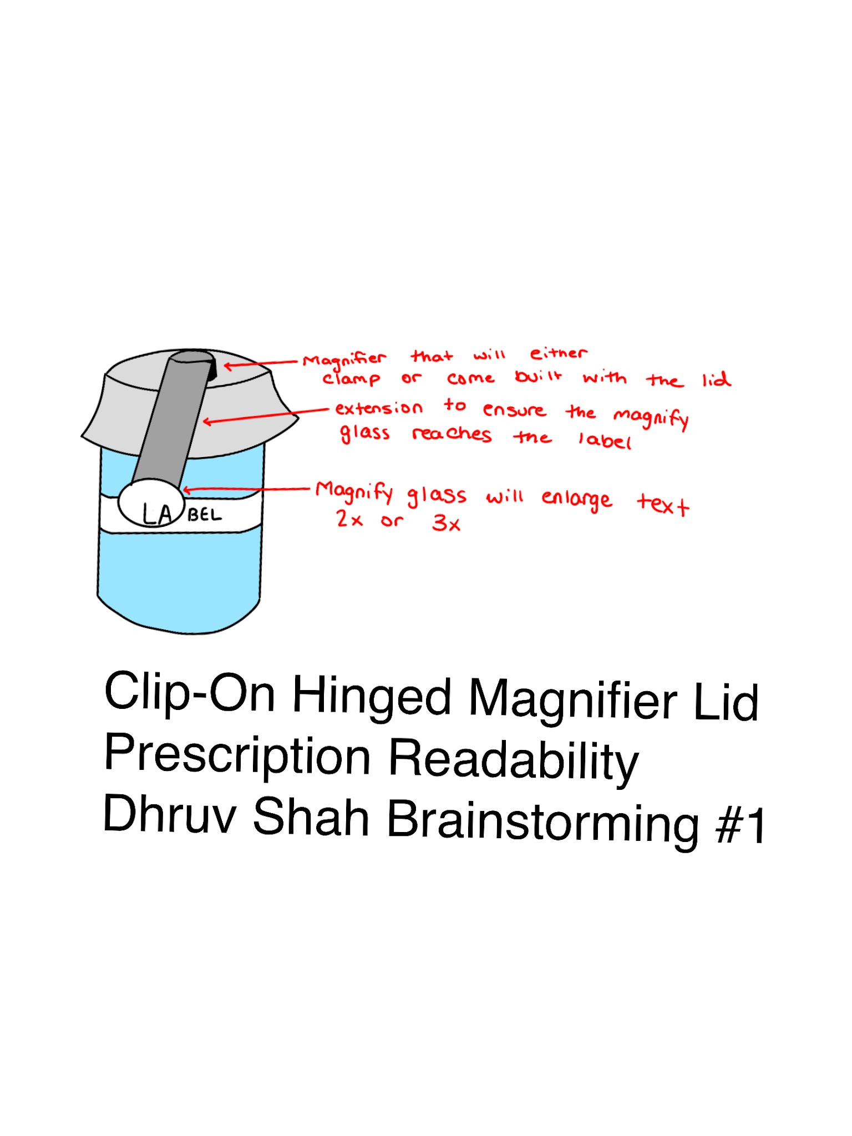

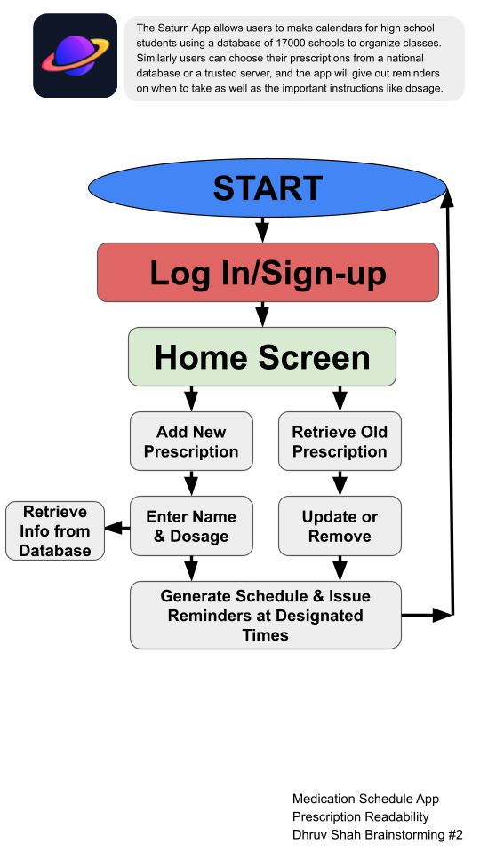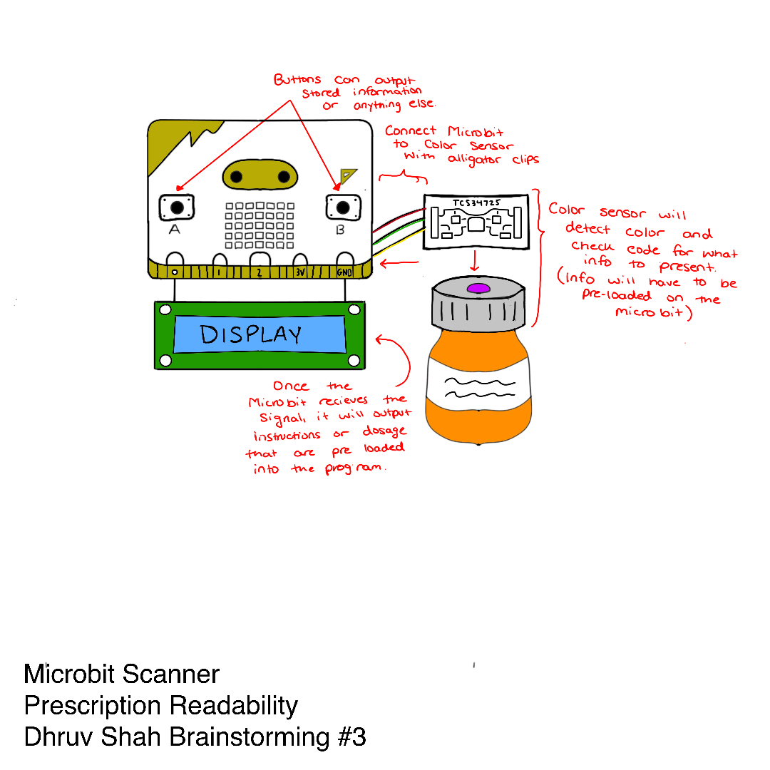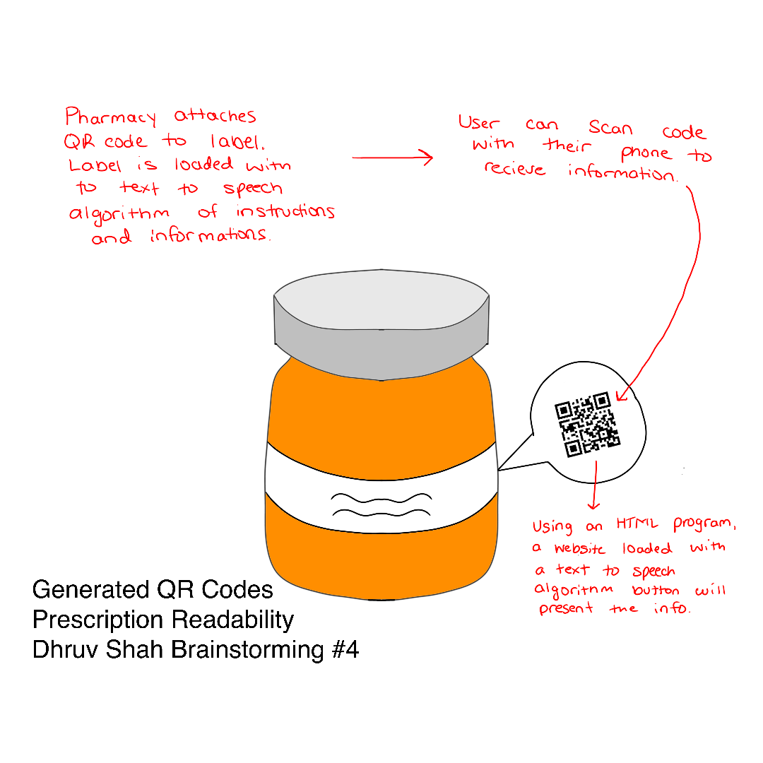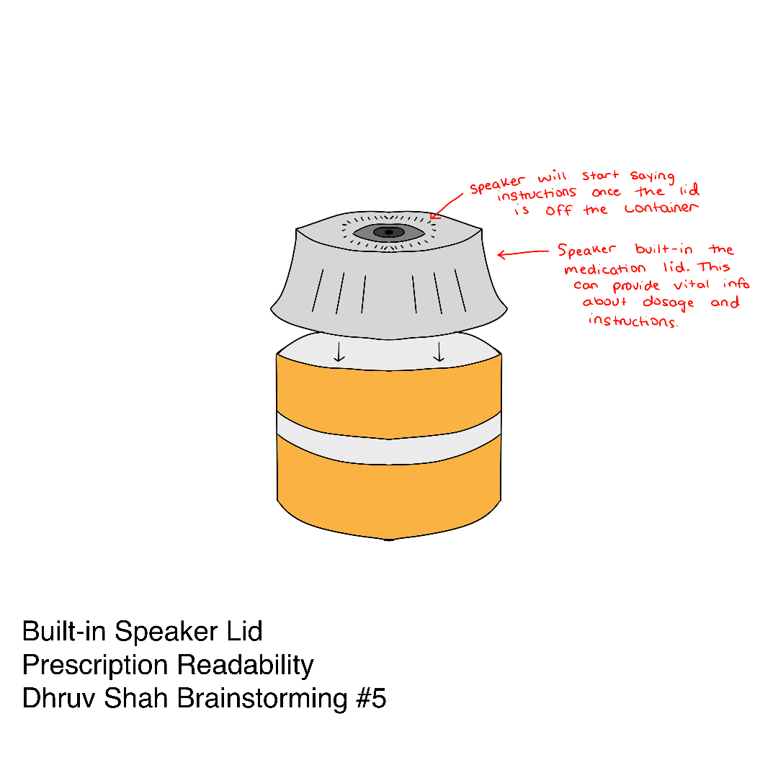

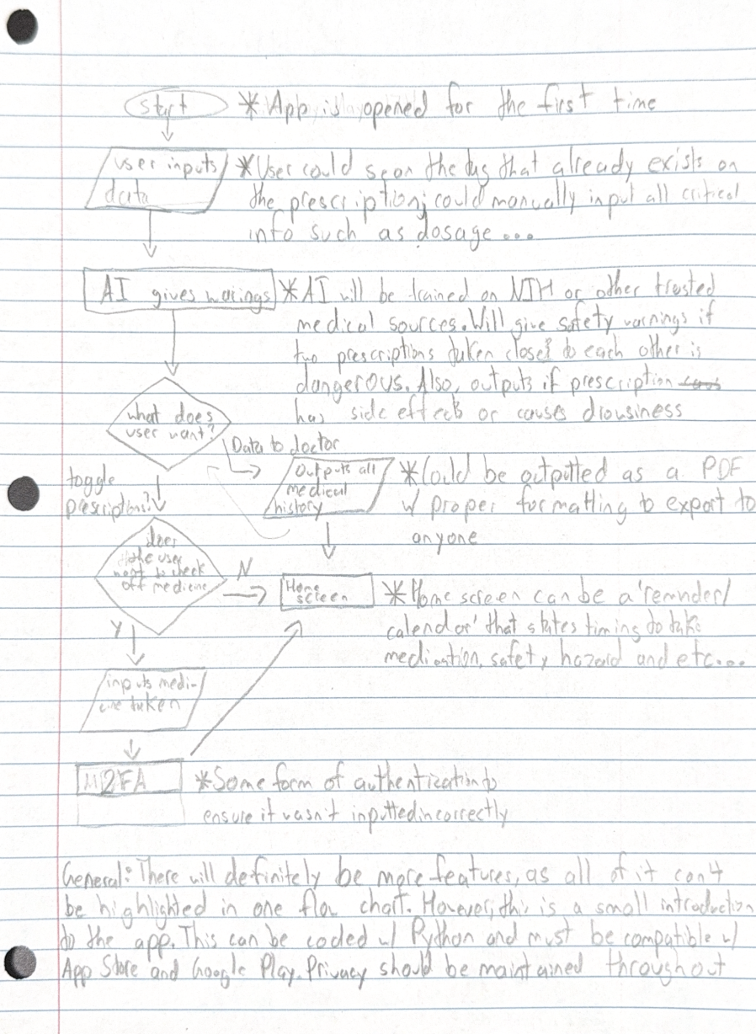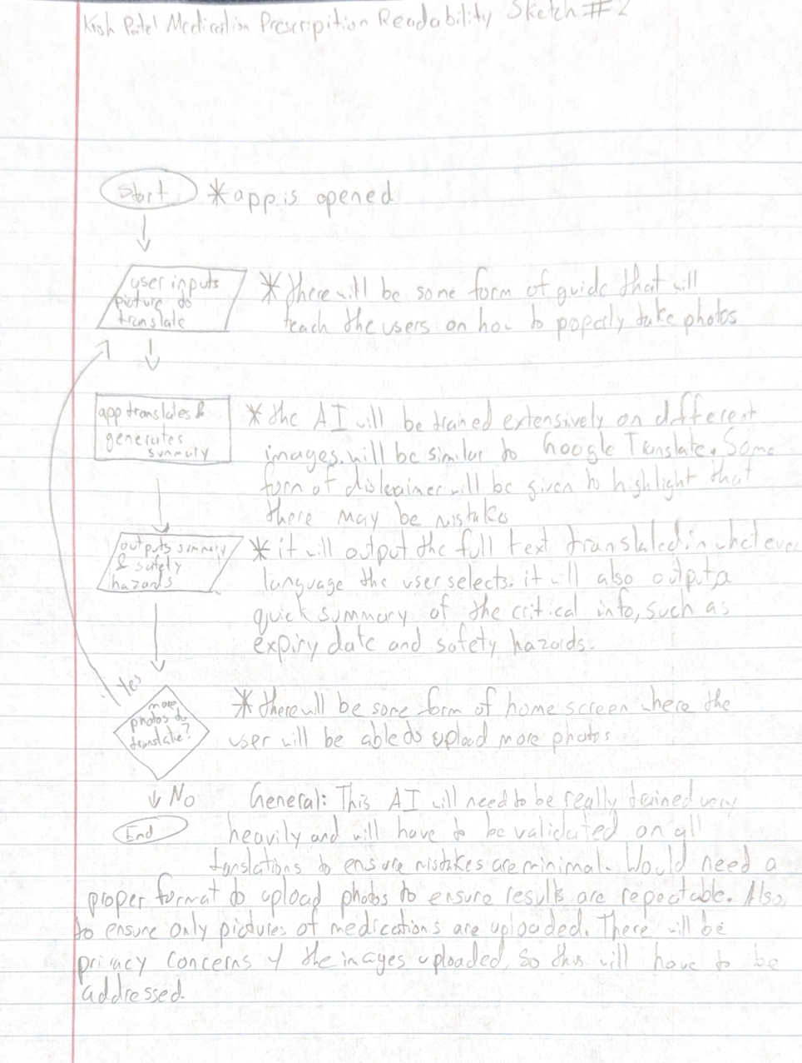

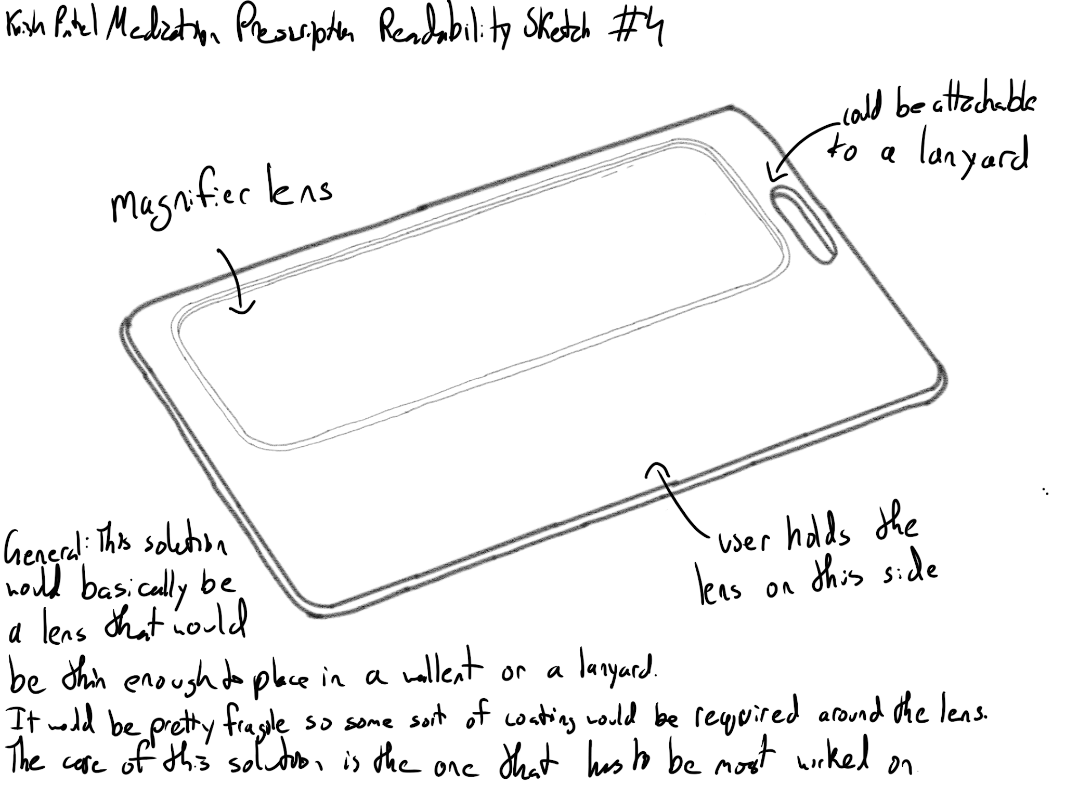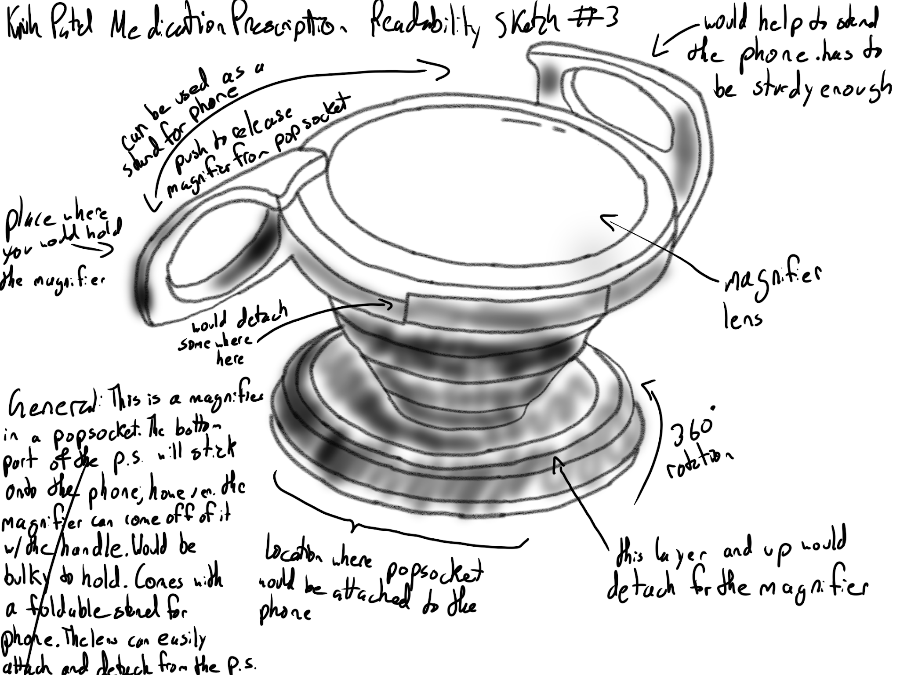

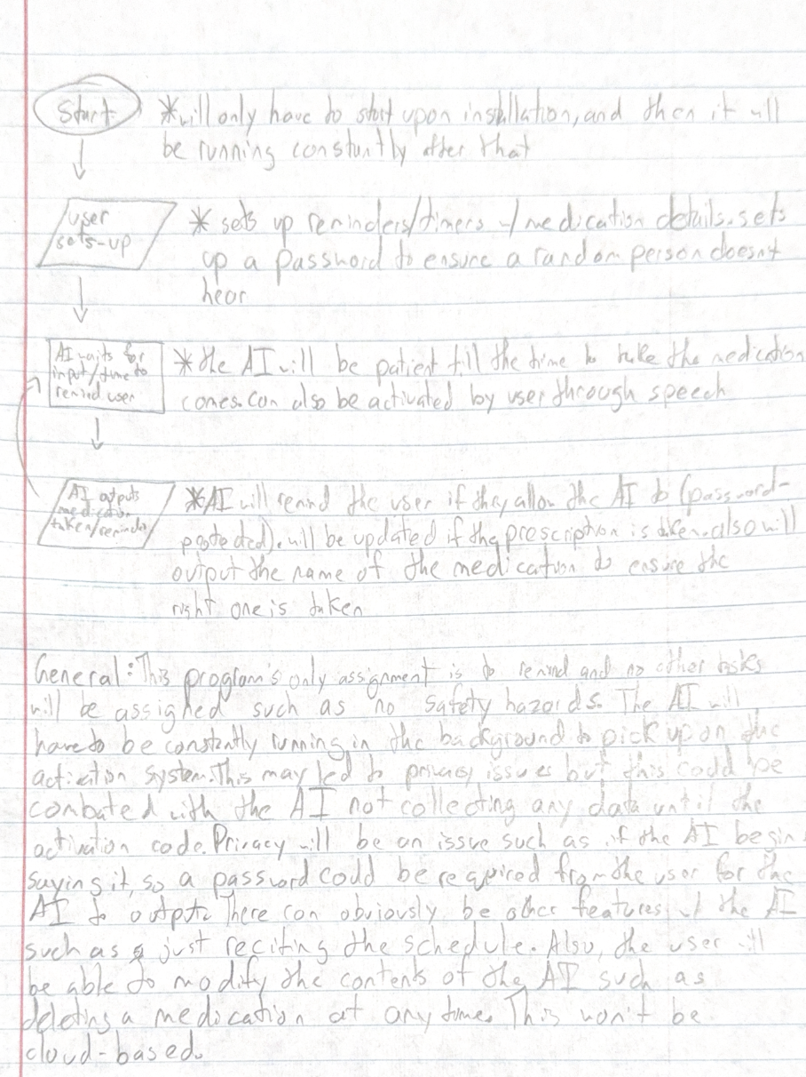
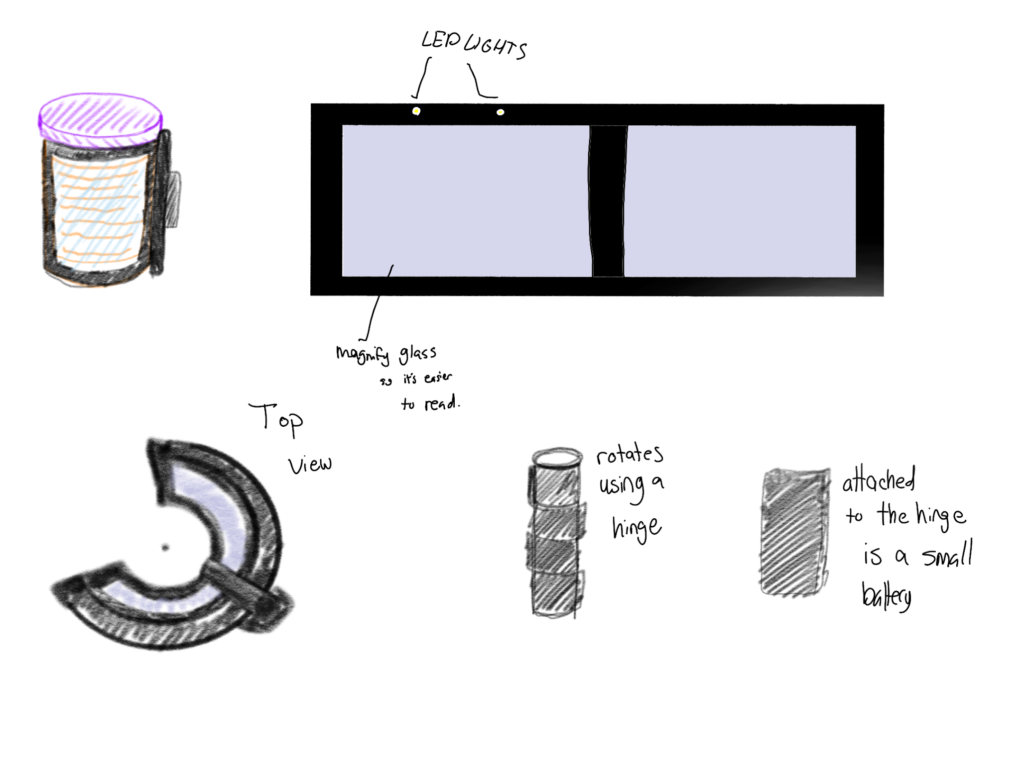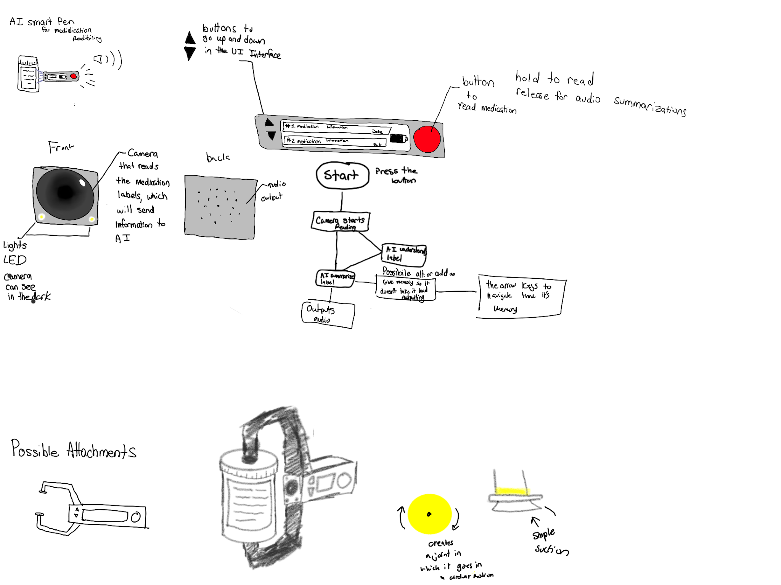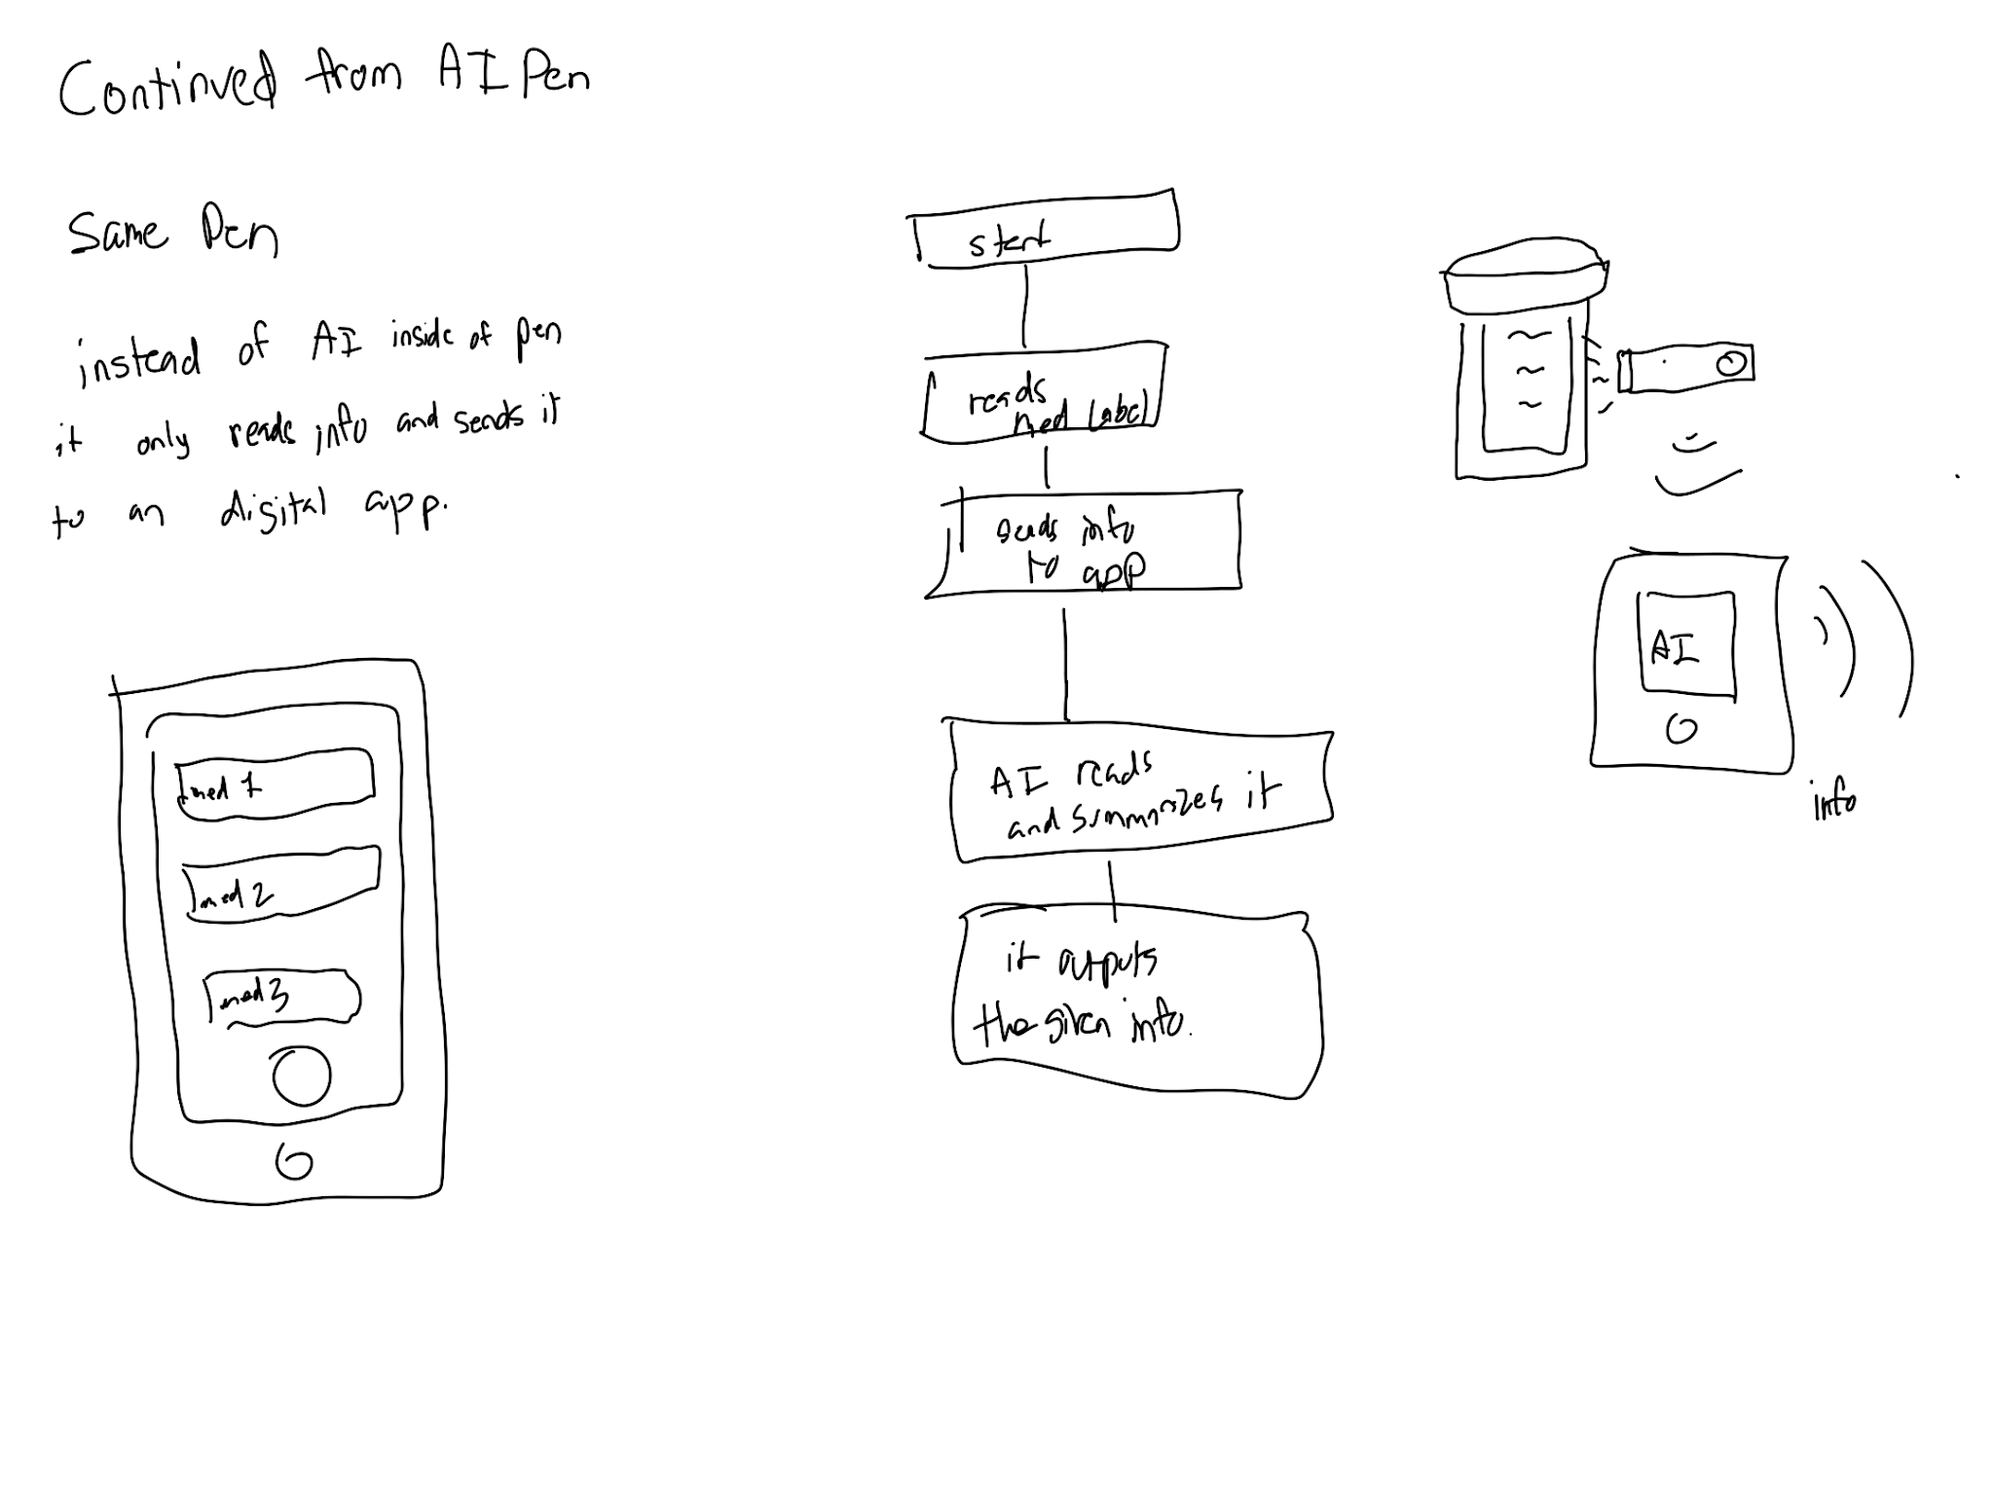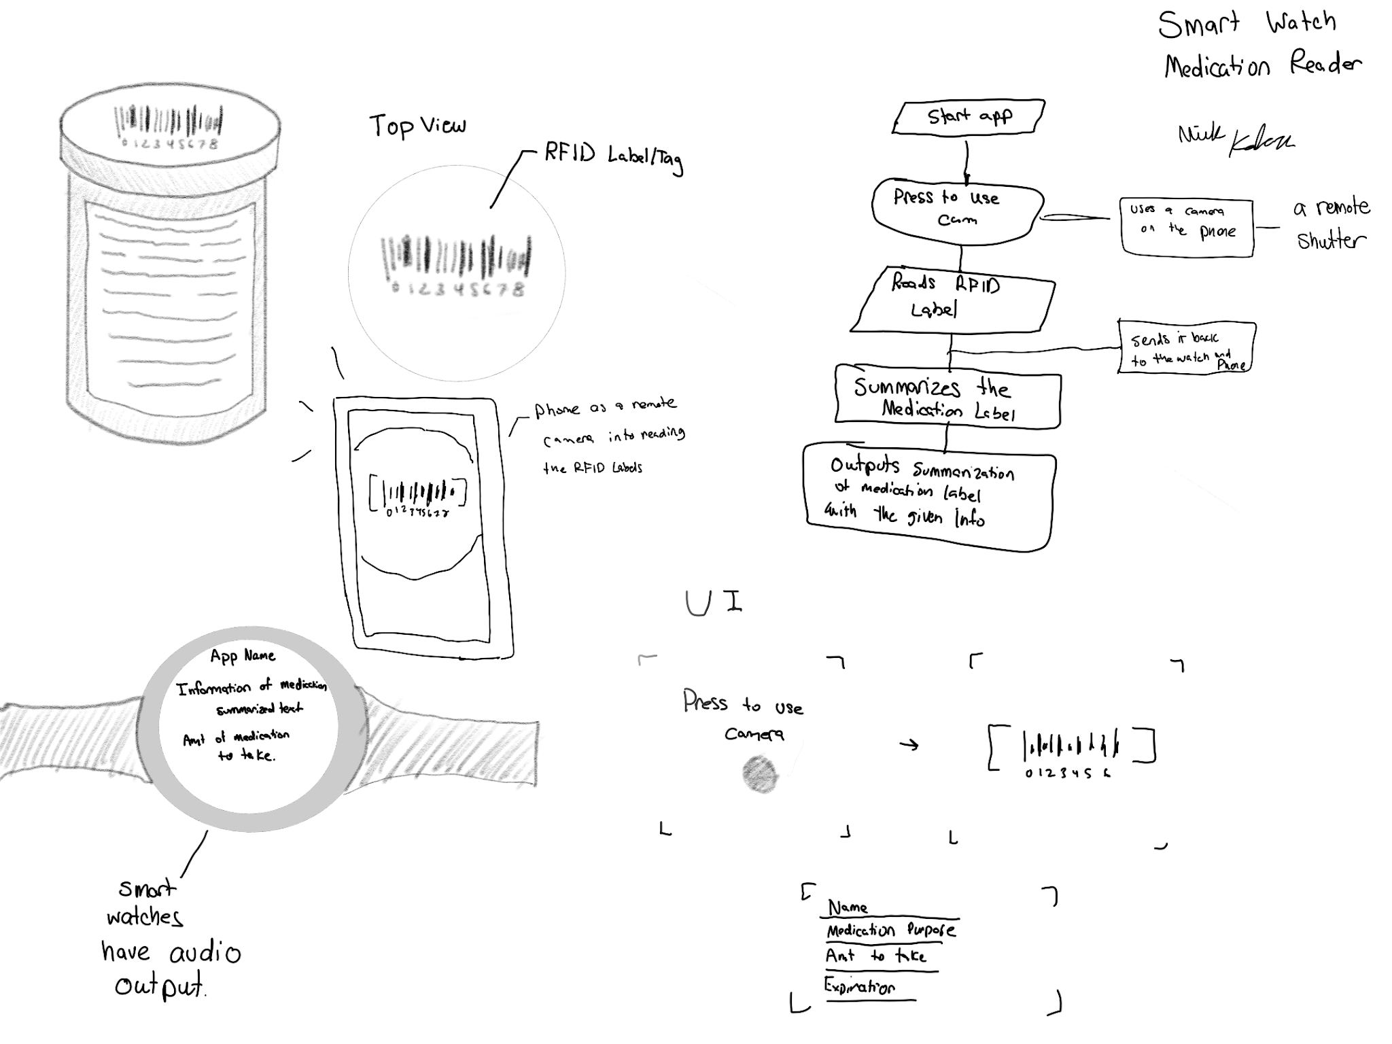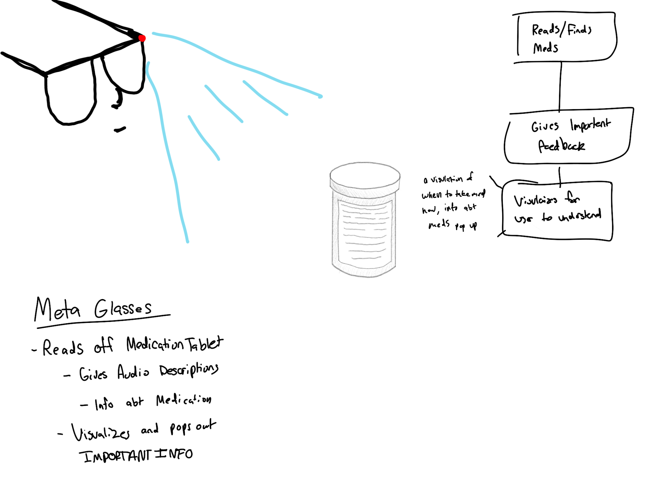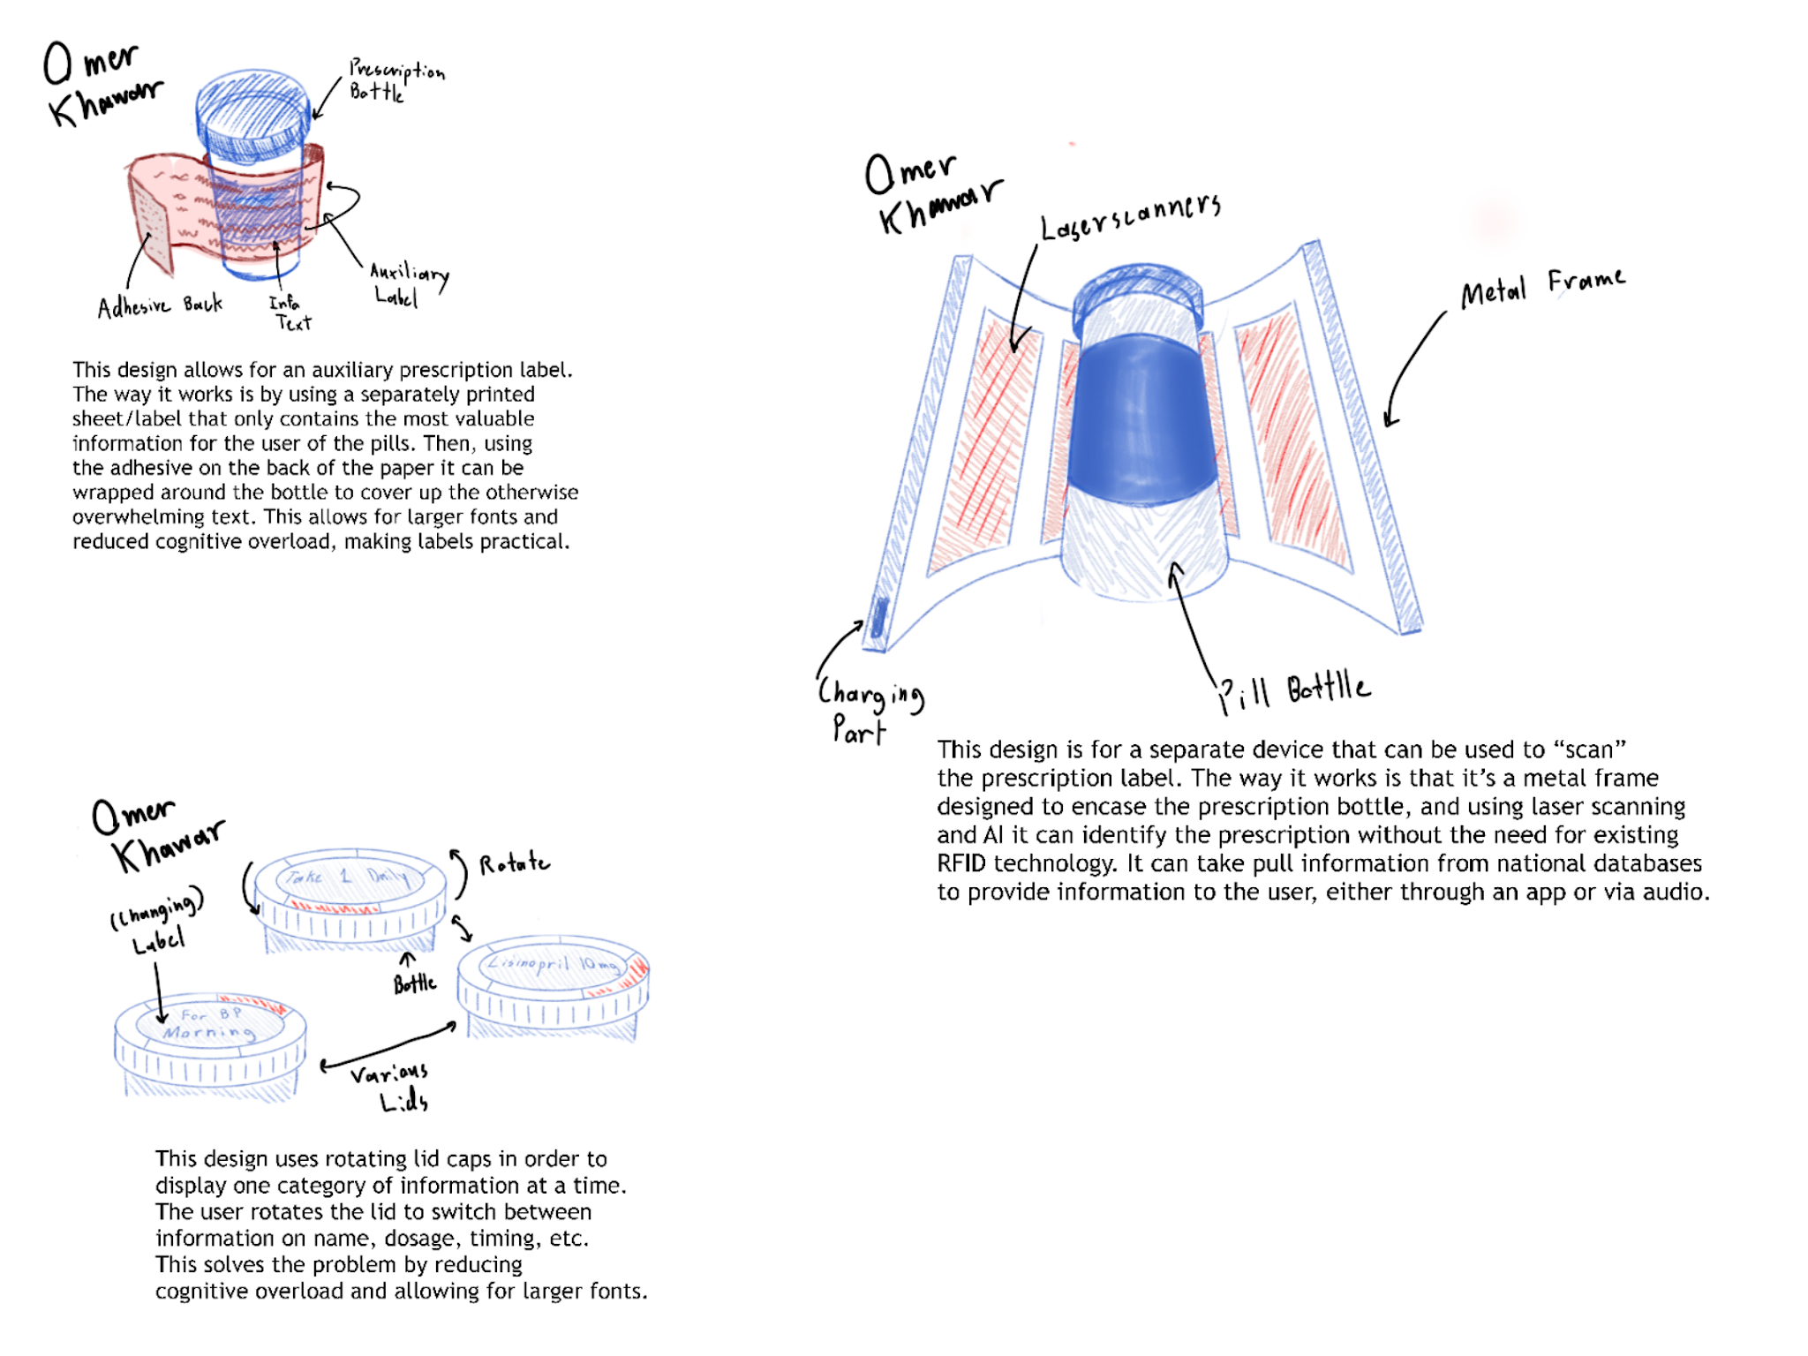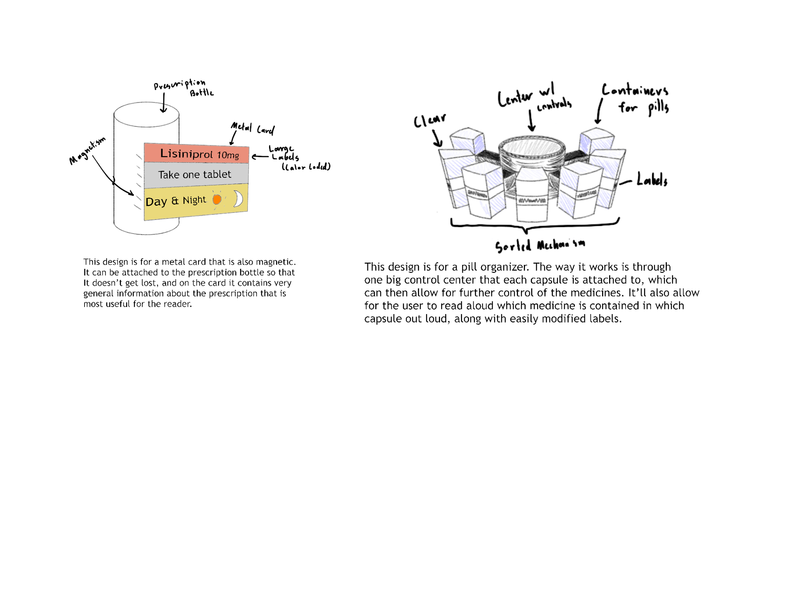

Problem Statement
Older adults often struggle to read and understand prescription labels due to age-related vision decline, small font sizes, poor label design, and complex medical instructions. Studies show that between 76 and 81 percent of older adults do not meet the visual requirements to read labels. 18% of individuals already experience medication errors. These challenges are greater for individuals managing multiple prescriptions, especially when pills appear similar or labels are in unfamiliar languages. Current solutions, such as pillboxes, caregivers, and talking RFID labels, offer support but are often costly, inaccessible, or require technological familiarity. This issue primarily occurs at home, where older adults manage medications independently. Therefore, there is a clear need for an affordable and accessible solution that improves label clarity, readability, and usability to reduce errors and enhance medication safety.

Design Criteria
- Safe & Accurate Use
- High Readability
- Ease of Use
- Confidence - Building

Final Three Concept Ideas
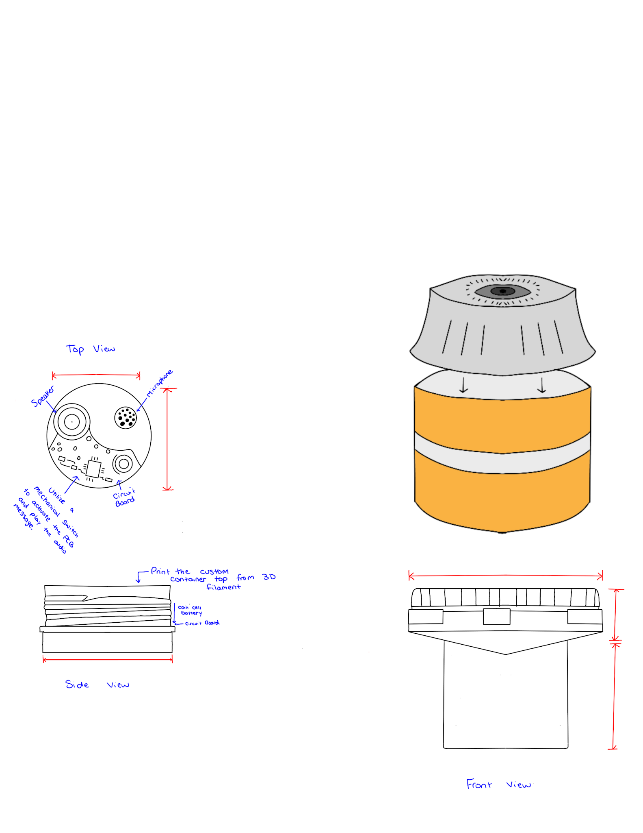
The design has a mechanical switch that activates the PCB to play the audio message. This message will be played from the speaker. The speaker and PCB will only be possible with a circuit board. There is a microphone attached; however, we are actively looking into how we can incorporate this and make it a functioning tool.
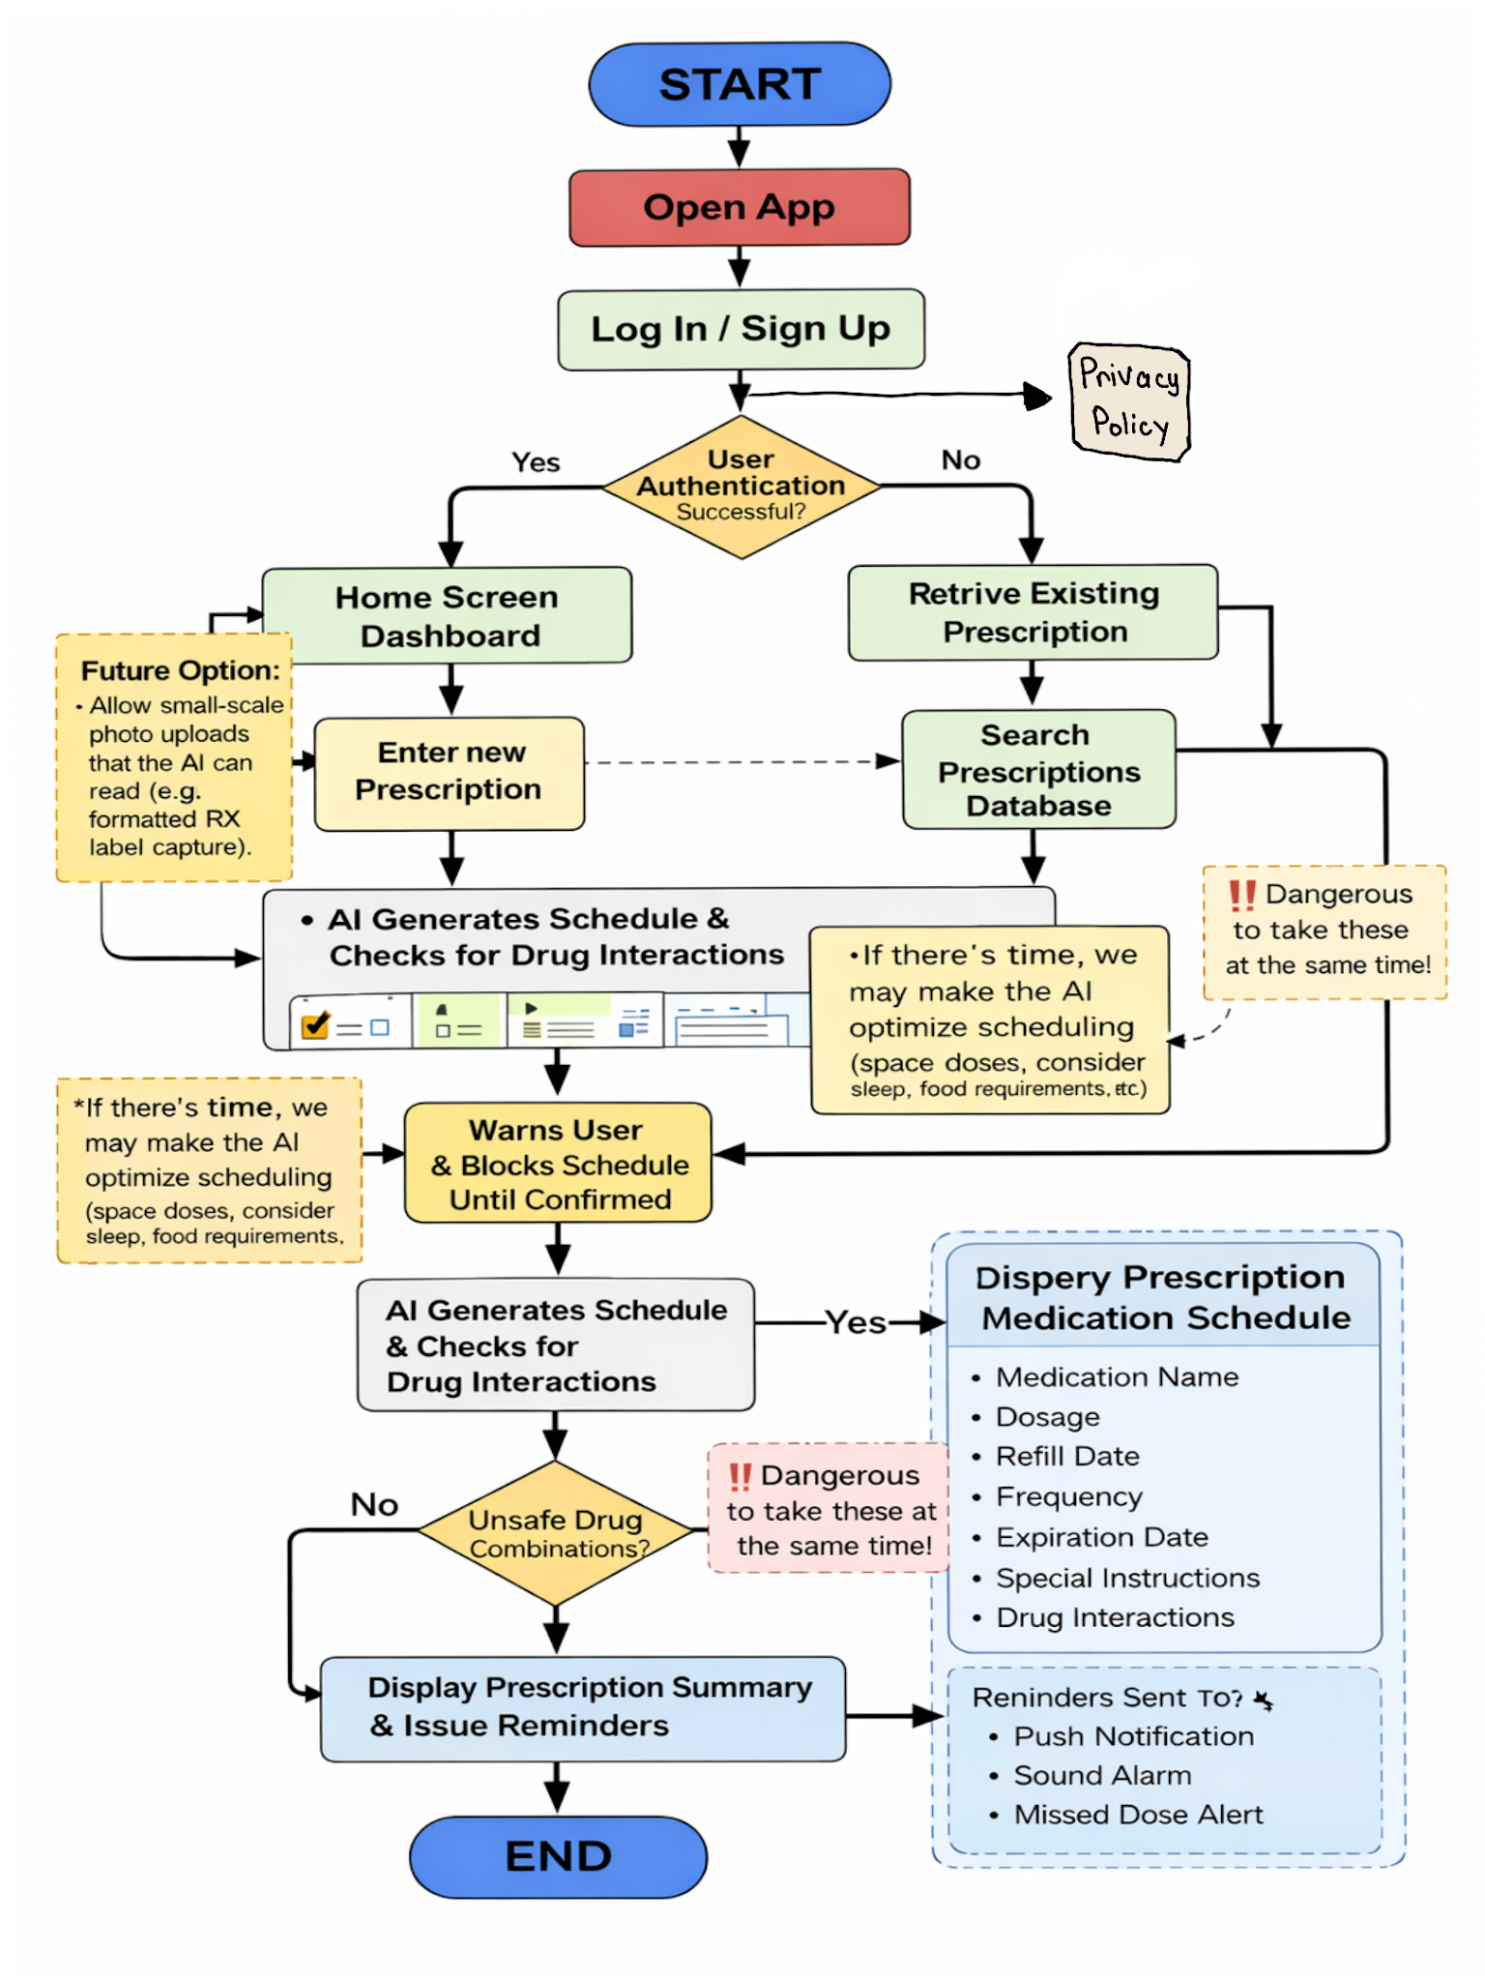A prescription app that tracks and generates a schedule and ensures drug safety when taking multiple prescriptions. The user will manually enter the prescription information. The app will remind the user of the prescription name, dosage, refill date, expiry date, and any special instructions. The app will also be able to set reminders to remind users to take medication. This will help users remember to take their medication if they have some form of memory loss
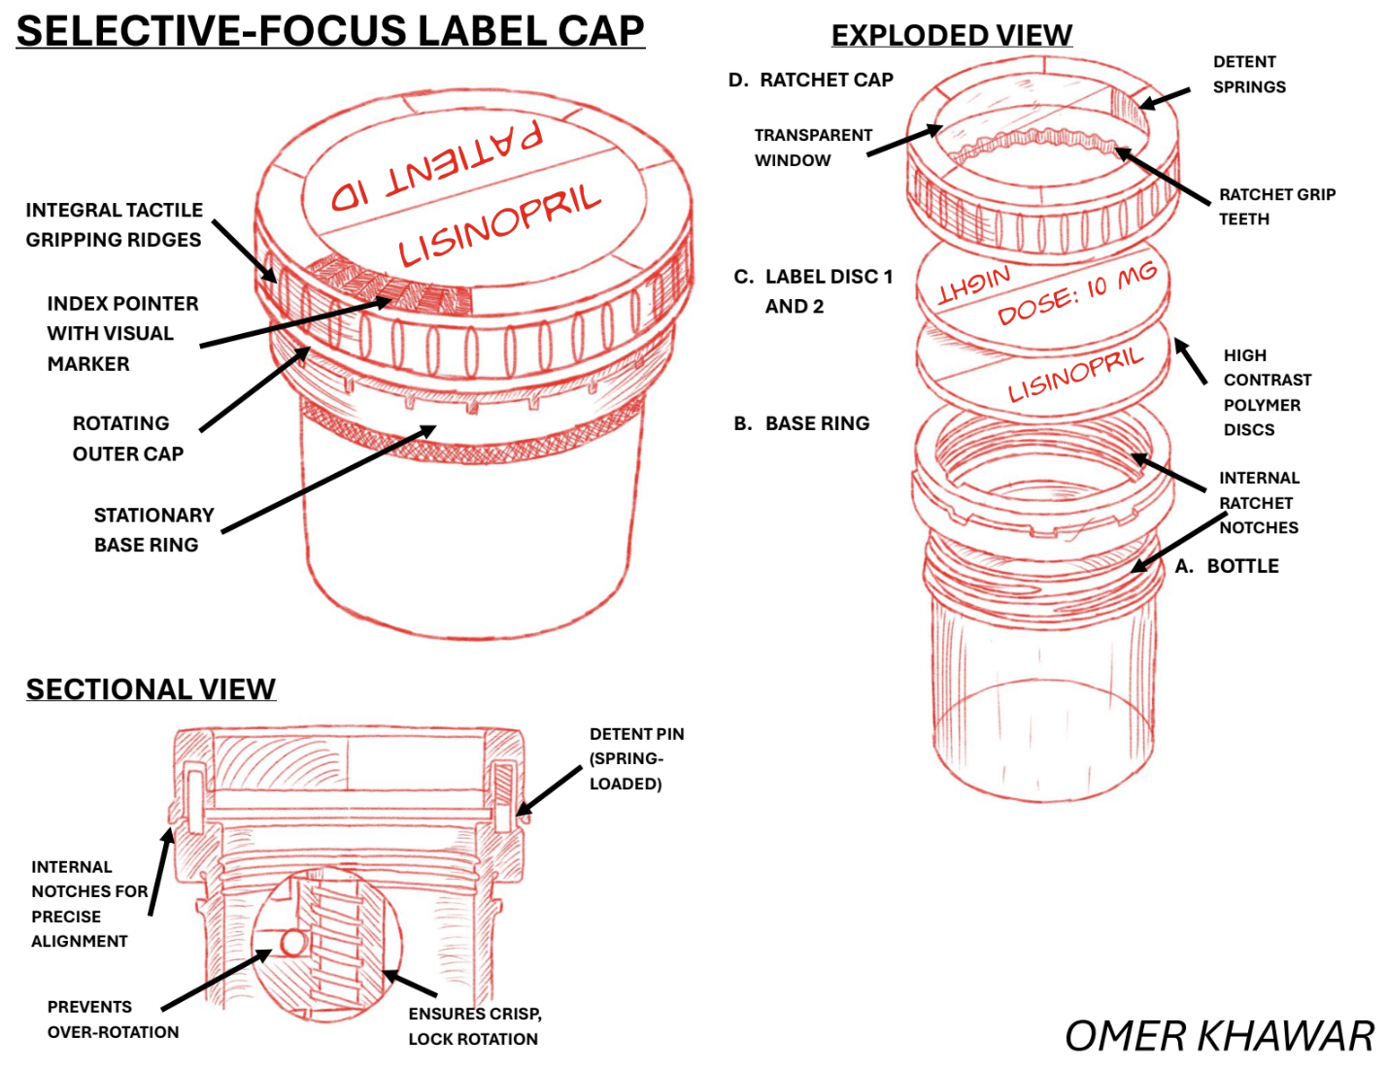
This product allows for a larger label to be displayed on the bottle cap of a prescription bottle. This label is very concise, containing only the most precise pieces of information, allowing for the largest font sizes possible. With a rotating cap design, users can then rotate the cap to then change what text is being displayed. In total, it allows for four different pieces of information to be displayed. This design doesn’t replace the existing label, making sure information isn’t lost.

Decision Matrix - 20 Solutions
Decision Matrix - 20 Solutions

The categories that we used to score the potential solutions are: Accessibility, Cost, Usability, Efficiency, and Development Time. We scored each category out of 5.

Final Three Concept Ideas
Final Three Concept Ideas Presentation

We presented this to our peers for constructive feedback.

Final Three Concept Ideas Survey

We will share this survey with other individuals so we can collect even further feedback.

Element D3 - Final Concept Selection Documentation
Element D3 - Final Concept Selection Documentation

Attached is the Element D3 documentation that contains: product description, operation, justification, consumer feedback, sketches/concepts, and more. This document will be readily available when individuals request the documentation of our final concept selection.

CAD
CAD Details

Attached are all of the CAD details such as the link to the Onshape, as well as the link to the Tinkercad circuit. The dimensions of the prescription bottle are also highlighted. The technical drawings of each part of the pill bottle will be added. Additionally, the circuit from the Tinkercad is visualized alongside the circuit for the circuit.

More pictures will be added down below.

Materials List
Materials List

Attached are all the expected materials that we will use to make the final product. More materials may be used, and likewise, less materials could be used. The purpose of each material is also highlighted.

Images of the CAD
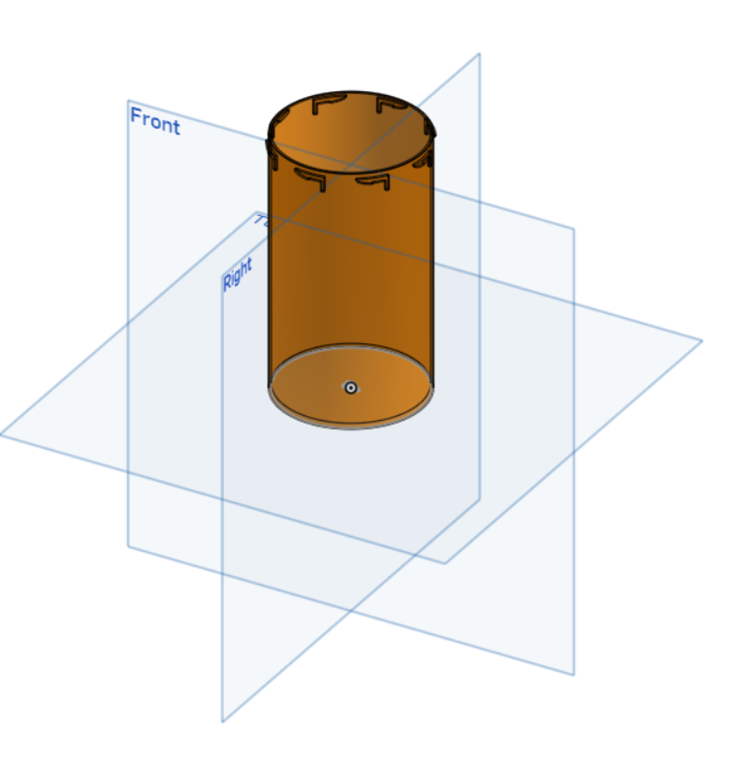
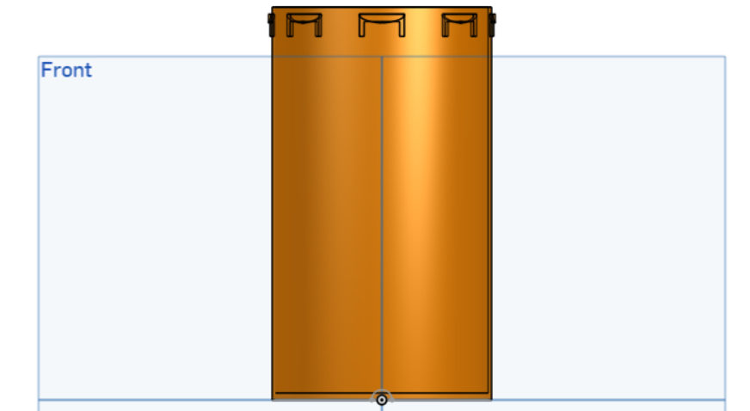
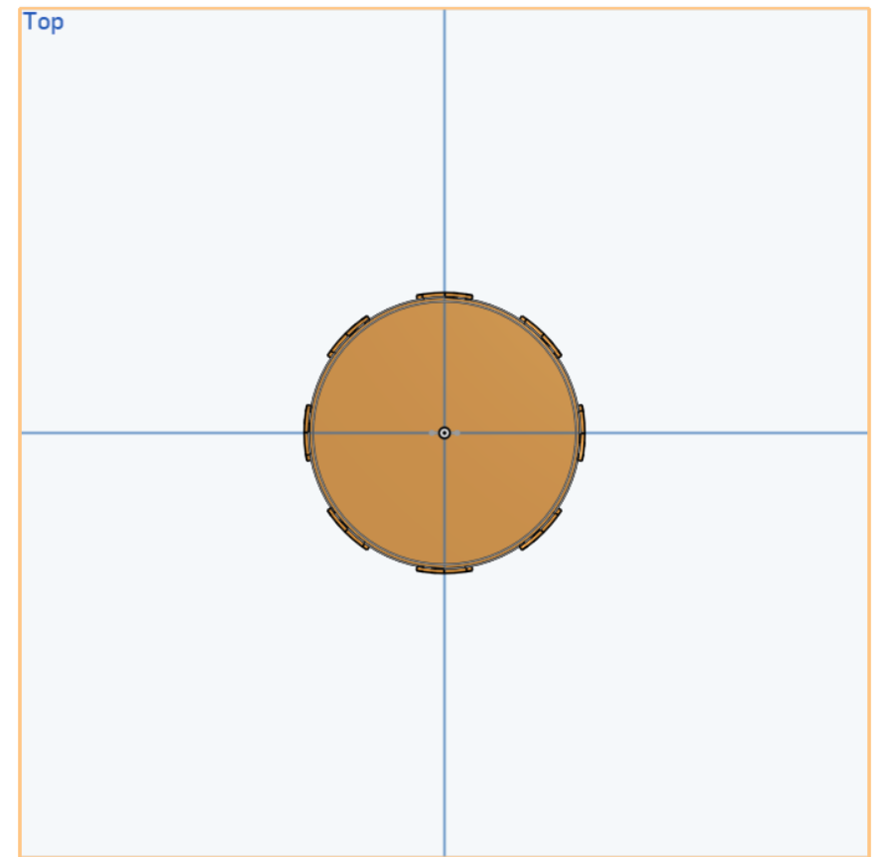
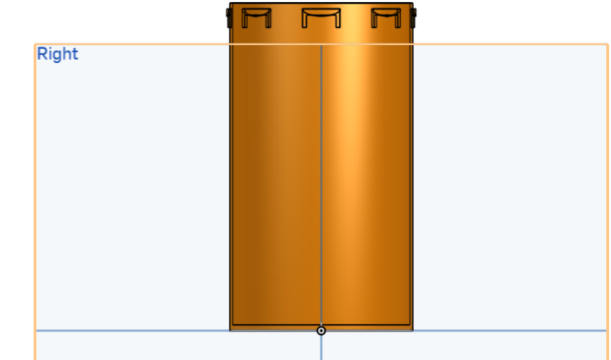
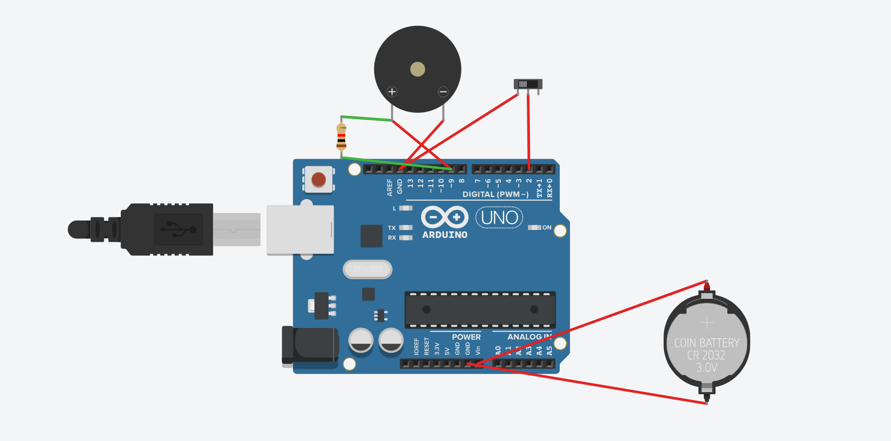
Sample Arduino Code:

int lidPin = 2; // Pin connected to the switch

void setup() {
pinMode(lidPin, INPUT_PULLUP); // Keeps pin HIGH until switch is flipped
pinMode(9, OUTPUT); // Pin for the Buzzer/Sound
}

void loop() {
// If the switch is moved (simulating lid removal)
if (digitalRead(lidPin) == LOW) {
// This "tone" represents your MP3 playing
tone(9, 880, 1000); // Play a 440Hz tone for 1 second
delay(5000); // Wait 5 seconds so it doesn't loop constantly
}
}
